Part 1
For this assignment, the overall problem will be creating an array of characters, and having a method which receives a user input and compares it to an element of the array, and if the elements matches the input, the next element of the array will be compared to the next input. For this assignment, I will use a main method, which will populate an array of charcters using a loop, open a scanner object and receive the user input, and depending on the user input it will call 1 of two methods, a method that iterates through the array of characters starting at the first index, or a method that starts at the last index. I will use a loop in the main method that will ask for a user input and check if the user input is either ‘s’ or ‘e’, signalling if the user would like to start at the start or end of the array. It will look something like this:

While (*input is not s or e) {
System.print(“enter an input”);
userInput = scanner.nextline();
if ( userInput == s ) {
AlphabetGameStart();
}
If (userInput == e ) {
AlphabetGameEnd();
}
Else {
System.print( “invalid input”);
}
Scanner.close();

The two methods for the actual alphabet game themselves will look somewhat similar and will behave nearly identically, except the one that starts at the first index will start at the first index of the array and will iterate towards the end of the array. If there is an incorrect answer, the loop will not iterate to the next element and and the counter (presumably ‘i’) will be i = i-1; for everytime there is an incorrect answer so as that the loop will ask to input the same requested value again. There will be a variable that will store the time when the method begins running, and another variable that stores the time when the method stops running. The time elapsed will be the difference between the two. This method will run until it reaches the end of the array. The other method that starts at the last index of the array will behave the same except the array will start at the last element and will iterate towards 0 ( the first index).

Part 2
import java.util.Scanner;
public class Main {
public static void main(String args[]) {
int n = 26; //length of alphabet
char[] alphabet = new char[n];
for (int i = 0; i < n; i++) {
alphabet[i] = (char) ('a' + i); //populates the alphabet array by using ASCII values that change through a loop
}
boolean choice = false; //boolean that represents a correct input (s or e)
Scanner scanner = new Scanner(System.in); //scanner is created
while (!choice) { //the program will continue to ask for an input as long as e or s has not been selected
System.out.println("\nChose to start from the start (type s) or the end (type e)");
String userInput = scanner.next();
// user input is stored. equals method is used to compare the user's input and decide if the aphabet is to be used from the start or the end
if ("s".equalsIgnoreCase(userInput.trim())) {
choice = true; // boolean is updated and loop ends
alphabetGameS(alphabet, n, scanner);
break;
}
if ("e".equalsIgnoreCase(userInput.trim())) {
choice = true; // boolean is updated and loop ends
alphabetGameE(alphabet, scanner);
break;
} else {
System.out.println("\nInvalid input. Valid inputs are 's' or 'e'"); //loop will continue to run as s or e hasn't been selected
}
}
scanner.close(); //scanner is closed
}
public static void alphabetGameS(char[] alphabet, int n, Scanner scanner) {
System.out.println("\nFirst letter is a");
long startTime = System.currentTimeMillis(); //timer is started
for (int k = 0; k < n; k++) {
String answer = scanner.next();
if(answer.equalsIgnoreCase(String.valueOf(alphabet[k])) && k < 25) { //checks if answer is correct and that the alphabet array hanst reached the end
System.out.println("\nCorrect! Next letter is: " + alphabet[k + 1]);
} else if (!answer.equalsIgnoreCase(String.valueOf(alphabet[k]))){
System.out.println("\nIncorrect! Try again");
k -= 1; //this removes that answer as a guess as it wasn't correct
}
if(answer.equalsIgnoreCase(String.valueOf(alphabet[n - 1])) && k == n - 1) { //once the last letter has been typed in and the array is on it's last element, the loop ends
System.out.println("\nSuccess! Game Over");
long endTime = System.currentTimeMillis(); //end time
double totalTime = (endTime - startTime) / 1000.0; //total time elapsed, in seconds
System.out.println("\nTotal time taken: " + totalTime + " seconds.");
break; //game is finished
}
}
}
// this method works much the same as the other one, except the array is used starting from the last element.
public static void alphabetGameE(char[] alphabet, Scanner scanner) {
System.out.println("\nFirst letter is z");
long startTime = System.currentTimeMillis();
for (int k = 25; k >= 0; k--) { //loop instead starts at the end of the array, and iterates towards zero, the first element
String answer = scanner.next();
if(answer.equalsIgnoreCase(String.valueOf(alphabet[k])) && k > 0) {
System.out.println("\nCorrect! Next letter is: " + alphabet[k - 1]);
} else if (!answer.equalsIgnoreCase(String.valueOf(alphabet[k]))){
System.out.println("\nIncorrect! Try again");
k += 1; // guess is removed as was incorrect
}
if(answer.equalsIgnoreCase(String.valueOf(alphabet[0])) && k == 0) { //once the last letter has been typed in and the array is on it's first element, the loop ends
System.out.println("\nSuccess! Game Over");
long endTime = System.currentTimeMillis();
double totalTime = (endTime - startTime) / 1000.0; //total time elapsed, in seconds
System.out.println("\nTotal time taken: " + totalTime + " seconds.");
break;
}
}
}
}

Part 3

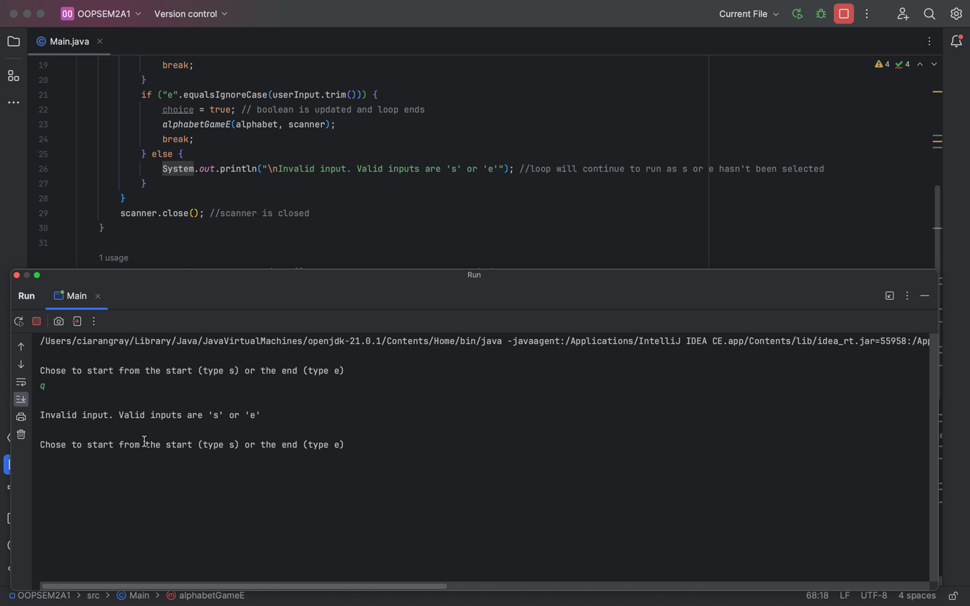

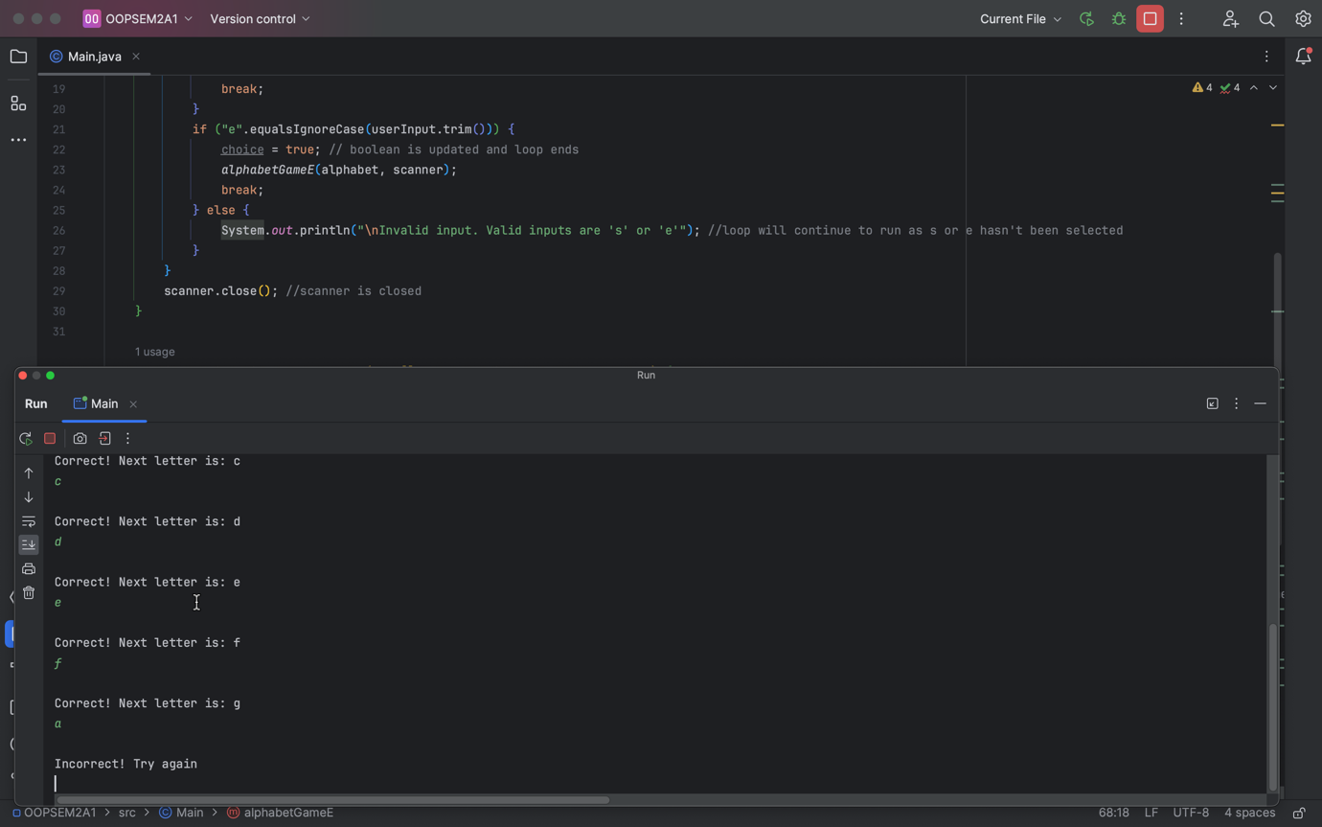

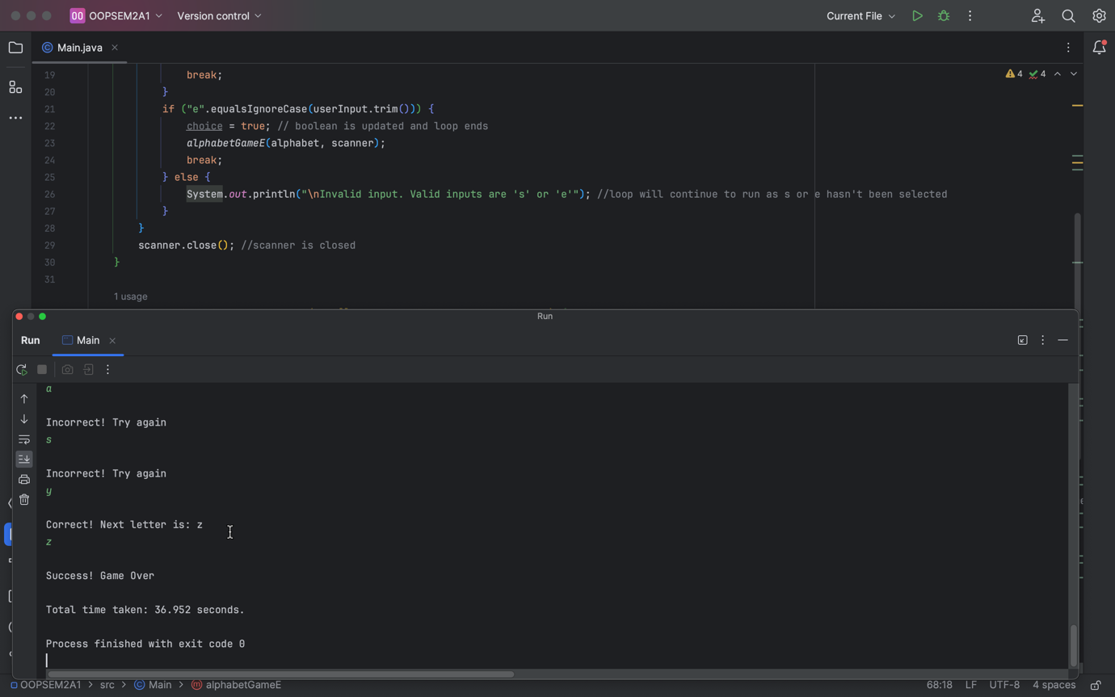

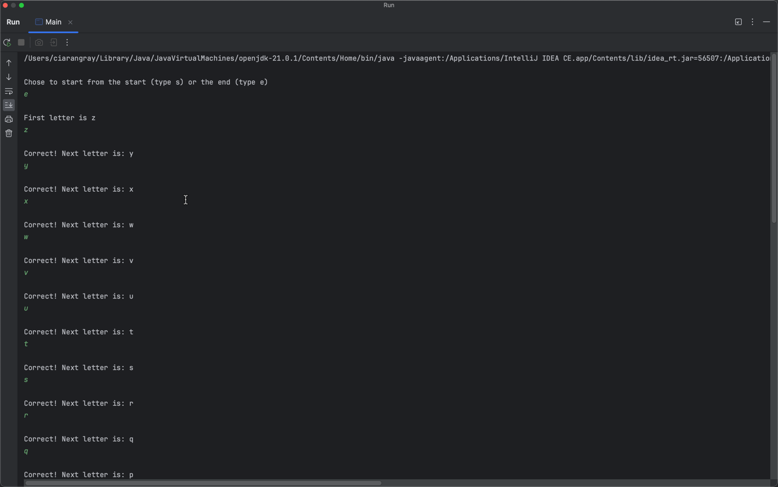

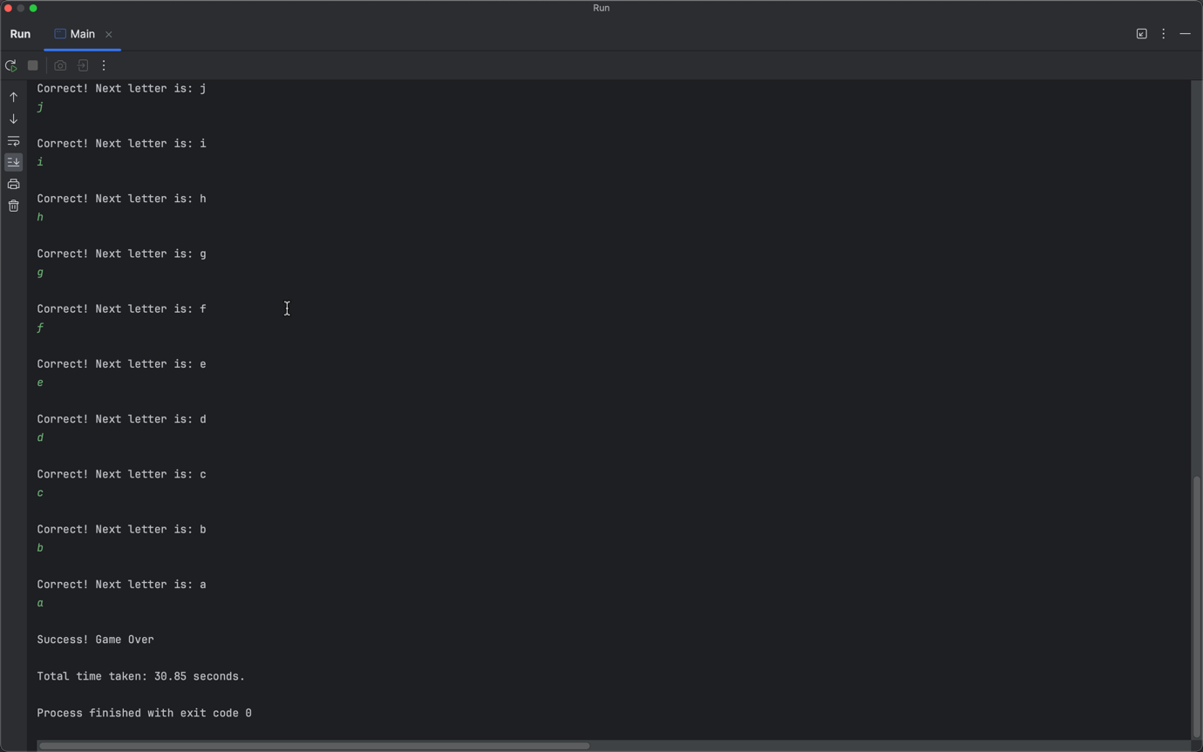

Expected Output | Actual Output
Iterating through the alphabet array and displaying what the next letter will be | Encountered an error when I reached the last letter of the array and couldn’t display the next letter
Comparing the current letter of the array to the user’s input | Made the common mistake of using ‘==’ instead of .equals to compare the characters

